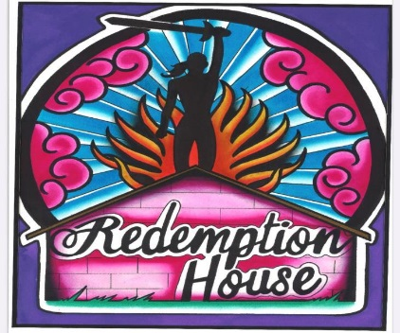

Identifying the Need

Human trafficking is the world’s fastest growing criminal enterprise and is an estimated $32 billion-a-year global industry. More than 40% of human trafficking cases in California occur in the Bay Area. Last year, more than 60 trafficking survivors were served by local agencies; many more remain unidentified.

Vision

Redemption House exists to overcome the bondage of human trafficking. Our vision is for every survivor of Human Trafficking to have the support and tools needed to create a happy, healthy future.

Mission

Redemption House is a comprehensive program of outreach to bring survivors out of trafficking and support services to allow them to rebuild their lives.

Our Accomplishments So Far

Street Outreach
Once a month, we meet survivors on the streets and in motels where they are trafficked to build rapport and make them aware of community resources. We give them self care kits, show them love and compassion and invite them to participate in our biweekly support group.

Support Groups
We meet twice a month, every first and third Thursday, at a confidential location. Survivors gather for a hot meal, spiritual support/meditation, self -care and an opportunity to check in and share. Survivors learn about community resources and interview skills to obtain employment. A clothing closet offers interview clothes.

Community Awareness
Redemption House advocates/survivors do presentations in the community — at community groups, schools, prisons and juvenile probation centers, mental health centers, bringing awareness of the effects of human trafficking and sharing our stories of hope and survival.

Mentoring
We do one-on-one interventions with adult and youth trafficking survivors. We meet them, share our stories, hear their stories and build rapport to let them know when they are ready to claim their healthy future, there is continuing support for them. When they are ready, survivors are able to move on to become advocates.

Our Future

Victims needs a safe place to recover from the effects of human trafficking and find a way to turn their pain into purpose. We plan to create a 12-month, 10-bed safe house program in Sonoma County to give them this space to recover and rebuild their lives.

Purpose

This event will bring awareness to the problem of human trafficking and the services we provide and invite community members and organizations to partner with us to fight human trafficking and support survivors.

How Can the Community Help?

Pray for the safety and healing of survivors and continued success in building our programs.

Give monetary donations to support our nonprofit organization. We also accept gift cards, food and blankets.

Prepare hot meals and hot coffee for our survivor support group.

Join us on outreach nights to prepare self-care kits, drive our outreach teams, or go into the community to make contact with survivors.

Partner with us — provide your expertise or resources to help us build our program. We need grant writers, financial and real estate professionals, handymen and contractors, as well as social service and healthcare professionals.

Our sponsor is Julie’s Purse Project - Federal Tax ID: 83-4416607

